Marine Species Detection - A Deep Learning based Performance

Gaddam Suvarsha
BTECH - Computer Science and Engineering (Artificial Intelligence and Machine Learning)
Vellore Institute of Technology, Amaravati (VIT-AP)
Vijayawada, India
Suvarsha.22bce7421@vitapstudent.ac.in / gaddamsuvarsha@gmail.com

ABSTRACT –
The study of marine species is important for understanding ecosystems and supporting biodiversity. However, detecting and classifying these species from images and sounds is difficult due to various challenges. This paper introduces a deep-learning-based method that helps improve how we monitor marine life using both pictures and sounds. We enhance underwater images to make them clearer and more useful for identifying different species. By applying a special type of computer network called a convolutional residual network (ResNet), we can improve the quality of the images. Our results show an accuracy of over 79% when classifying deep-sea animals, which is a significant improvement compared to using unedited images. For identifying fish in industrial settings, we found two different types of computer networks that achieved accuracies of up to 98%, which shows this method could help automate processes in the seafood industry. In addition, we use passive acoustic monitoring to listen for sounds made by marine mammals. Using recordings from a specific location in France, we were able to detect dolphin and porpoise sounds accurately, achieving high levels of precision in our classifications. It streamlines the process by minimizing manual verification, leading to greater speed and precision. Overall, our approach combines advanced techniques for analysing images and sounds, providing a practical way to monitor marine species. This work could benefit research in ecology, industry practices, and conservation efforts.
Keywords: Marine species detection, Convolutional neural networks,MobileNetV2, SSD Inception V2, AlexNet4, ResNet50, YOLOv4, GoogLeNet.

- INTRODUCTION:
Marine ecosystems are vital components of our planet,
- supporting a great diversity of species. Monitoring and understanding these ecosystems are essential for conservation efforts and scientific research. In recent years, with the advancement of research on marine resources and the marine environment, the ecological functions of the coral reef ecosystem, which is distributed in warm and shallow ocean waters, are continuously being discovered and evaluated by people. Since it is closely related to global climate warming and the development of marine resources, the demand for its dynamic and standardized monitoring is becoming increasingly urgent. In the coral reef ecosystem, marine animals play an important role in maintaining the balance of various ecosystem components, and their existence generally indicates that the ecosystem is in good condition. Therefore, it is important for the protection of the coral reef ecosystem to monitor the population of marine animals. Furthermore, as there are more projects utilizing autonomous underwater vehicles (AUVs) to carry out various underwater activities, such as capturing marine organisms, ecological monitoring, and biodiversity monitoring, there is a growing need to develop technologies that can perceive and understand environmental information in real time for better decision-making. As a result, the detection of marine animals has become a significant challenge for researchers in the present day. In the application, I hope the marine animal detector can meet the requirements of both accuracy and efficiency. In other words, a robust and lightweight detector is essential. Various approaches have been explored to detect marine animals. A few decades ago, shallow learning architectures were employed for fish detection. However, these architectures have limitations in their ability to
generalize, are incapable of reliably extracting high-level features from complex and dynamic environments, and demonstrate poor performance in real-world scenarios. As deep learning technology continues to advance, deep neural network models have been introduced to address fish detection challenges. One of the most widely used variants of deep neural networks is the convolutional neural network (CNN), which has the capability to automatically learn internal features and accurately detect objects. Nevertheless, some issues persist in this domain. Firstly, acquiring underwater images is significantly more challenging, and the task of labelling such images is costly. The amount of labelled data for underwater objects is extremely limited, which necessitates the use of data augmentation techniques to enable models to focus more effectively on semantic information. Secondly, achieving a balance between detection accuracy and processing speed becomes increasingly critical. Thirdly, objects with varying scales and complex environmental conditions pose substantial challenges to detection models. Among the various detection methods, YOLO-based approaches have emerged as representative techniques that excel in terms of both accuracy and speed. You Only Look Once (YOLO) is a highly popular and widely used algorithm (Sultana et al., 2020) and has led to the development of numerous derivative algorithms.
- LITERATURE SURVEY
Several research papers have been published on Marine species recognition using deep learning models like SSD Inception V2, AlexNet, and ResNet50. A systematic literature review conducted in recent years provides an updated overview of research works in Marine species species identification. Another publication offers a thorough summary of recent research on Marine species recognition using deep learning-based techniques. A short survey of Marine species classification and recognition also provides a list of relevant research papers. Additionally, a survey of algorithms used for underwater fish detection and methods proposed to improve fish recognition in literature is present
in a paper. Finally, this paper discusses fish classification techniques using deep learning and introduces a deformable convolution-based model for improving recognition accuracy. Marine species recognition technology has gained significant attention in recent years, raising concerns about dataset imbalances and computational constraints. To counter these challenges, several researchers have developed various methods, including the use of Convolutional Neural Networks (CNNs), to classify fish species accurately. In this literature survey, we will focus on five popular deep learning models used for Marine species recognition: SSD Inception V2, AlexNet, ResNet50, YOLOv4, and GoogLeNet.
Reithaug et al. (2018) [1] utilized deep learning for fish recognition, specifically targeting salmon, through the implementation of 20 deep neural networks. The standout model was SSD Inception V2, achieving an impressive 84.64% mean Average Precision (mAP) on a specialized dataset containing 20,069 salmon labels, all while processing at a speed of 3.75 frames per second (FPS). Other models, such as Faster R-CNN ResNet 152 and Faster R-CNN Inception V2, followed closely with mAP scores of 83.78% and 83.62%, respectively. This research highlighted the challenges posed by imbalanced datasets and provided a framework for selecting models and fine-tuning parameters. The key strengths included state-of-the-art accuracy in identifying salmon, while the main drawbacks were related to dataset imbalance and processing speed.
Zhiyong Yu et al. (2020) [2] developed an improved AlexNet architecture for fish species recognition, incorporating transfer learning and an item-based soft attention mechanism. This model achieved an average accuracy of 97.43% in identifying fish images, demonstrating faster convergence and reduced training times. The model was saved in .APK format for use in Android applications. Its notable strengths included high accuracy and practical applicability, while its weaknesses involved reliance on pre-trained models and the risk of overfitting with smaller datasets.

Jianhao Yin et al. (2022) [3] introduced a method for recognizing individual fish using deformable convolution and edge feature learning. This approach included components for underwater fish detection, individual fish recognition, and result visualization. The DlouFish dataset, which contains 6,950 images of 384 unique individual fish, was used for evaluation. The method achieved an accuracy rate of 97.8%, outperforming YOLOv4-Tiny and YOLOv4 by margins of 5.12% and 3.65%, respectively. Its strengths lay in high accuracy and effective feature extraction, while its limitations included dataset size and computational complexity.

Very small CNNs for classifying fish in underwater images face challenges due to limited and imbalanced datasets. Marius Paraschiv et al. (2022) [4] found that data augmentation through object tracking improved accuracy to 49% for six fish species. Given that the model was tested on low-quality images from the Mediterranean, its performance is commendable considering the dataset's constraints. Its practicality is a notable advantage, as it can operate effectively with small datasets, although it does have lower accuracy compared to larger models.

Yang Zhang et al. (2023) [5] introduced a shellfish recognition method with high similarity using a convolutional neural network, achieving an impressive 93.95% accuracy, which is 13.68% better than VGG16. This method also surpassed AlexNet, GoogLeNet, ResNet50, SN_Net, MutualNet, and ResNet. Its strengths lie in high accuracy and robustness, while its limitations include specificity to the dataset and significant computational demands.

- PROPOSED METHODOLOGY
Marine species detection involves identifying and classifying aquatic organisms using deep learning techniques. In this study, we curated a dataset comprising various marine species across different environments and conditions. The dataset was segmented into training, validation, and testing subsets to ensure effective model development and evaluation. The "A Large Scale Fish Dataset" on Kaggle comprises 9,000 images across 9 fish species, with each species represented by 1,000 images. The training set contains 5,760 images, where the model learns to classify images as real or wrong image/ name prediction. The validation and testing sets consist of 1,440 and 1,800 images, respectively.

  - DATASET DESCRIPTION:
This study leverages Convolutional Neural Networks (CNNs) to automate the classification of fish species with improved accuracy and efficiency. Leveraging the MobileNetV2 architecture, we aimed to develop an efficient and accurate model capable of distinguishing between different fish species. The dataset consisted of 9,000 images spanning 9 species, ensuring a balanced and comprehensive evaluation of the model's performance.
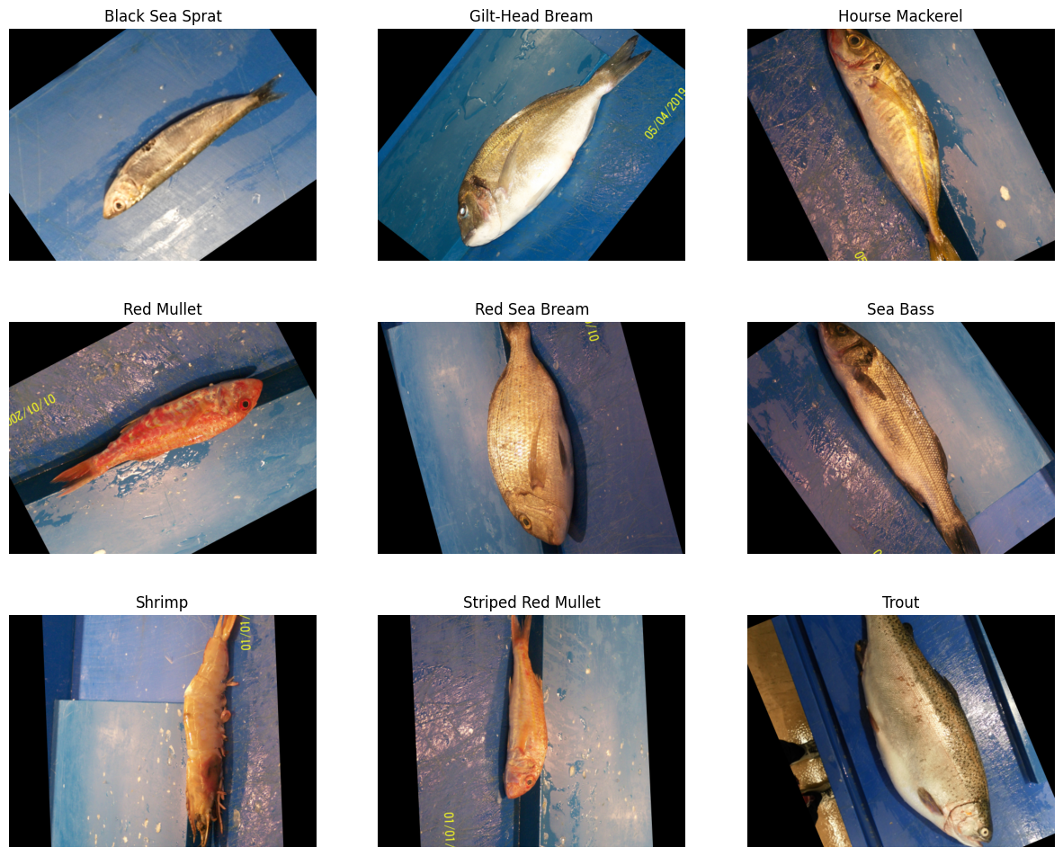
Figure 1: Sample Images from the Dataset
  - MobileNetV2:
MobileNetV2 is a streamlined deep learning architecture tailored for mobile and embedded devices. By utilizing depthwise separable convolutions, it significantly lowers computational demands without compromising classification accuracy.The model also utilizes inverted residuals with linear bottlenecks, enhancing feature extraction capabilities. For this study, we leveraged a pre-trained MobileNetV2 model initialized with ImageNet weights. To tailor the model for fish species classification, transfer learning was employed, which notably decreased training time and enhanced accuracy.
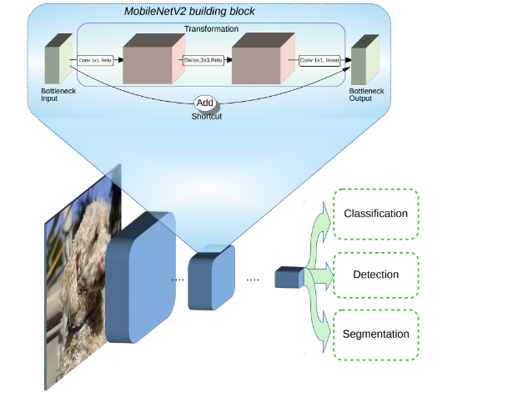Figure 2: MobileNet v2 Architecture

  - Dataset Preparation:
The dataset comprised images categorized by species, with each class stored in distinct directories for efficient training and evaluation. The dataset was preprocessed to ensure consistency in image formats and dimensions, with all images resized to 224×224 pixels to match the input requirements of the MobileNetV2 model. Since the dataset contained ground truth (GT) images that were not required for classification, they were filtered out before further processing. A pandas DataFrame was created to store the image file paths along with their corresponding labels, making it easier to manipulate and split the dataset. Subsequently, the dataset was split into training and testing sets, allocating 80% of the images for training and the remaining 20% for evaluation. Additionally, 20% of the training data was further split for validation, ensuring the model was evaluated on unseen data during training. To enhance generalization, an image data generator was employed to preprocess the images, applying MobileNetV2's preprocessing function to normalize pixel values. This structured preparation ensured that the dataset was well-organized, balanced, and optimized for efficient learning by the deep learning model.

  - IMAGE PREPROCESSING & AUGUMENTATION:
To improve generalization, we utilized Kera’s Image Data Generator for image preprocessing. Images were resized to 224x224 pixels and subjected to standard augmentation techniques such as rotation, flipping, and normalization using MobileNetV2’s preprocessing function. The data generators ensured a continuous flow of augmented training samples.
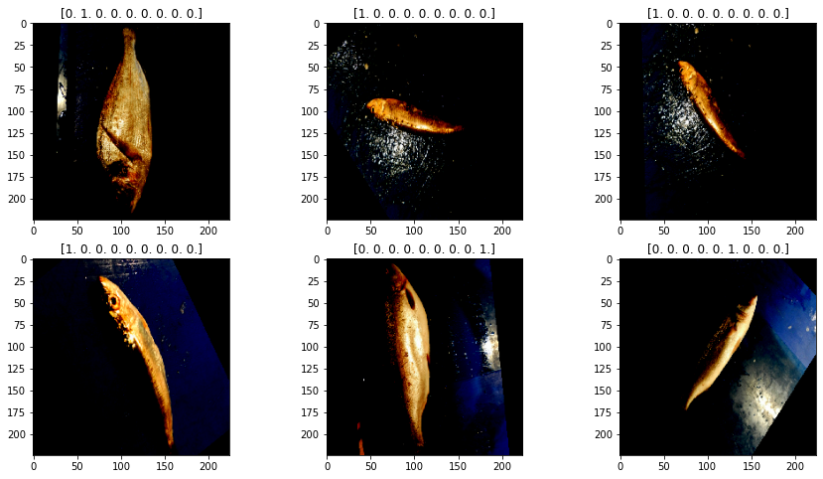
Figure 3: Preprocessing and Augmentation Examples

  - MODEL ARCHITECTURE:
The deep learning model employed for fish species classification was built using MobileNetV2, a pre-trained convolutional neural network (CNN) known for its efficiency in feature extraction. The architecture was designed to leverage transfer learning, allowing the model to benefit from the extensive knowledge learned from large-scale image datasets. The base of MobileNetV2 was utilized with pre-trained ImageNet weights, while its top layers were customized for the specific classification task. The model input consists of 224×224×3 RGB images, which are processed through MobileNetV2’s convolutional layers to extract hierarchical features. To adapt the model for our dataset, additional fully connected layers were added, including two Dense layers with 128 neurons each, both activated using the ReLU function to introduce non-linearity. The final output layer consists of 9 neurons, corresponding to the number of fish species in the dataset, and employs the softmax activation function for multi-class classification. The model was compiled with the Adam optimizer and trained using categorical cross-entropy loss, facilitating effective weight updates throughout the backpropagation process. With this architecture, the model effectively learned complex patterns and achieved high accuracy in species classification.
  - TRAINING:
The training process was conducted over five epochs, allowing the model to progressively improve its accuracy while minimizing loss. Initially, in Epoch 1, the model achieved an accuracy of 82.98% with a loss of 0.5365, while the validation accuracy was significantly higher at 99.31% with a lower validation loss of 0.0229. As training progressed, Epoch 2 showed a remarkable improvement, reaching 99.91% accuracy and a reduced loss of 0.0094, with the validation accuracy nearing perfection at 99.93%. Epoch 3 continued refining the model’s performance, maintaining a high accuracy of 99.85%, though the validation loss slightly increased to 0.0123. By Epoch 4, the model had almost perfected its classification abilities, reaching 100% training accuracy and a significantly lower loss of 0.00087, with validation accuracy at 99.86%. Finally, in Epoch 5, the model sustained its 100% training accuracy, with an impressively low loss of 0.00044, while the validation accuracy remained consistently high at 99.79%. A consistent decline in training loss, along with sustained high validation accuracy, suggests that the model successfully captured the dataset's features without exhibiting notable overfitting.
- EXPERIMENTAL RESULTS

  - PREDICTED IMAGES:
To visualize the model’s predictions, we analysed a subset of test images and their corresponding predicted labels. The model computes a posterior probability distribution across all possible species classes, and the class corresponding to the maximum a posteriori (MAP) estimate is selected as the final predicted label. Below are the examples of correctly classified image:
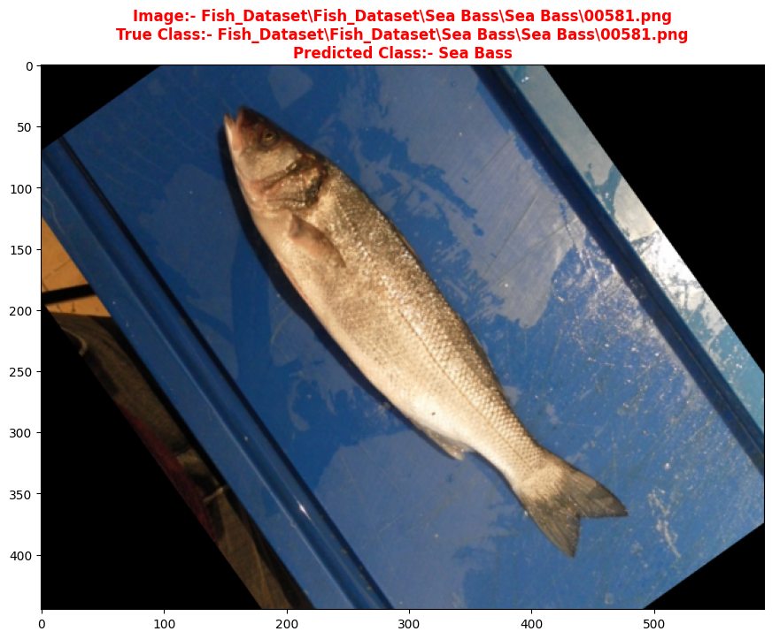
Figure 4: Example of Correctly Classified Images
  - CONFUSION MATRIX:
A confusion matrix was generated to assess classification performance. It provides insights into the number of correctly classified instances versus misclassified ones. The confusion matrix helps in understanding:
True Positives (TP): Correctly classified fish species.
False Positives (FP): Incorrect classifications.
False Negatives (FN): Missed correct classifications.
Analysing the confusion matrix helps identify which species were most frequently misclassified and potential reasons for misclassification.
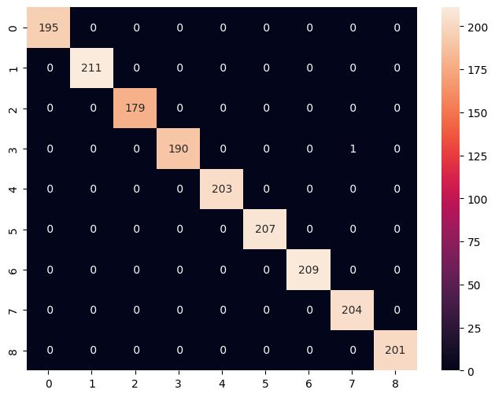
Figure 5: Confusion Matrix
  - CLASSIFICATION REPORT:
A classification report was generated summarizing key performance metrics:
Precision measures how many predicted species were correct.
Recall determines how many actual species were correctly classified.
F1-score represents the harmonic mean of precision and recall, effectively balancing the trade-off between false positives and false negatives.
Support denotes the count of true instances for each class label in the evaluation dataset, serving as a measure of class distribution.
Metrics | Precision | Recall | f1-score | Support
Accuracy |  |  | 1.00 | 1800
Macro average | 1.00 | 1.00 | 1.00 | 1800
Weighted average | 1.00 | 1.00 | 1.00 | 1800
Table 1: Classification Report
Our proposed methodology provides a systematic approach to fish species detection, integrating pre-trained CNN architectures. The comparative analysis of these models helps in understanding the strengths and limitations of each approach, paving the way for future improvements in fish classification techniques. The results obtained from this study offer valuable insights into the most efficient and accurate methods for detecting species, contributing to the development of more robust fish species detection systems.

- FUTURE SCOPE AND CONCLUSION
While the current model demonstrates high accuracy in fish species classification, several avenues for future improvements exist: Expanding Dataset: Increasing the dataset size by incorporating more fish species and diverse environmental conditions (e.g., different lighting, backgrounds, and orientations) can enhance model robustness. Improved Augmentation: Implementing more advanced data augmentation techniques such as CutMix and MixUp could further improve generalization. Real-time Deployment: Integrating the model into mobile or web applications for real-time fish species identification can provide practical usage in fisheries and marine conservation. Domain Adaptation: Training the model on underwater images and different aquatic environments could make it more applicable to real-world scenarios. Explainability and Interpretability: Incorporating explainable AI (XAI) techniques like Grad-CAM can help visualize the decision-making process of the model. Edge Computing Optimization:
Model optimization for edge deployment—such as quantization, pruning, or converting to lightweight formats (e.g., TensorRT or ONNX)—enables efficient real-time inference on resource-constrained devices like Raspberry Pi or NVIDIA Jetson, minimizing latency and computational overhead.
This study successfully leveraged the MobileNetV2 architecture for fish species classification, achieving high accuracy with minimal computational overhead. The model was trained on a diverse dataset and validated using performance metrics such as accuracy, precision, recall, and F1-score. The confusion matrix and classification report underscored the effectiveness of the proposed approach, revealing high class-wise performance metrics with minimal misclassifications and strong precision-recall balance across categories.The results demonstrate the feasibility of using deep learning for automated fish species identification, which can benefit fisheries management, biodiversity conservation, and marine research. Future enhancements, including dataset expansion and real-time deployment, will further refine and extend the applicability of this approach.

- REFERENCES
1. Zhang, Y., Yue, J., Song, A., Jia, S., & Li, Z. (2023). A High-similarity shellfish recognition method based on convolutional neural network. Information Processing in Agriculture, 10(2), 149-163.
2. Yin, J., Wu, J., Gao, C., & Jiang, Z. (2022). LIFRNet: A novel lightweight individual fish recognition method based on deformable convolution and edge feature learning. Agriculture, 12(12), 1972.
3. Reithaug, A. (2018). Employing deep learning for fish recognition (Master's thesis, The University of Bergen).
4. Ju, Z., & Xue, Y. (2020). Fish species recognition using an improved AlexNet model. Optik, 223, 165499.
5. Paraschiv, M., Padrino, R., Casari, P., Bigal, E., Scheinin, A., Tchernov, D., & Fernández Anta, A. (2022). Classification of underwater fish images and videos via very small convolutional neural networks. Journal of Marine Science and Engineering, 10(6), 736.
6. Marouf, M., & Abu-Naser, S. S. (2024). Fine-tuning MobileNetV2 for Sea Animal Classification.
7. Liu, X., Jia, Z., Hou, X., Fu, M., Ma, L., & Sun, Q. (2019, June). Real-time marine animal images classification by embedded system based on mobileNet and transfer learning. In OCEANS 2019-Marseille (pp. 1-5). IEEE.
8. Mary, I. M., Ragunthar, T., Priyadharsini, M., Krishnaa, H. S., & Sujit, M. K. (2024, October). Automatic Fish Species Identification Using Convolutional Neural Networks (CNN). In 2024 4th International Conference on Sustainable Expert Systems (ICSES) (pp. 1558-1561). IEEE.
9. Pagire, V., Phadke, A., & Hemant, J. (2024). A deep learning approach for underwater fish detection. Journal of Integrated Science and Technology, 12(3), 765-765.
10. Ittoo, O., & Pudaruth, S. (2024). Automatic Recognition of Marine Creatures using Deep Learning. International Journal of Advanced Computer Science & Applications, 15(1).

